**Sonatype Nexus System Requirements**

1. Minimum 1 VCPU & 2 GB Memory
2. Server firewall opened for port 22 & 8081
3. OpenJDK 8
4. All Nexus processes should run as a non-root nexus user.

**Note**: For production setup, please consider minimum production hardware requirements based on the nexus usage and data storage. Check out the [official system requirements document](https://help.sonatype.com/repomanager3/installation/system-requirements)for detailed information

**Sonatype Nexus 3 on Linux ec2**

This article guides you to install and configure Sonatype Nexus 3 in a secure way on an ec2 Linux System.

**Note**: This was tested on a Redhat machine and it will work on Centos or related Linux flavors as well.

**Step 1:** Login to your Linux server and update the yum packages. Also install required utilities.

sudo yum update -y

sudo yum install wget -y

**Step 2:** Install OpenJDK 1.8

sudo yum install java-1.8.0-openjdk.x86_64 -y

**Step 3:** Create a directory named app and cd into the directory.

sudo mkdir /app && cd /app

**Step 4:** Download the latest nexus. You can get the latest download links fo for nexus [from here](https://help.sonatype.com/repomanager3/download).

sudo wget -O nexus.tar.gz https://download.sonatype.com/nexus/3/latest-unix.tar.gz

Untar the downloaded file.

sudo tar -xvf nexus.tar.gz

Rename the untared file to nexus.

sudo mv nexus-3* nexus

**Step 5:** As a good security practice, it is not advised to run nexus service with root privileges. So create a new user named nexus to run the nexus service.

sudo adduser nexus

Change the ownership of nexus files and nexus data directory to nexus user.

sudo chown -R nexus:nexus /app/nexus

sudo chown -R nexus:nexus /app/sonatype-work

**Step 6:** Open /app/nexus/bin/nexus.rc file

sudo vi /app/nexus/bin/nexus.rc

Uncomment run_as_user parameter and set it as following.

run_as_user="nexus"

**Step 7:**If you want to change the default nexus data directory, open the nexus properties file and change the data directory -Dkaraf.data parameter to a preferred location as shown below. If you don’t specify anything, by default nexus data directory will be set to /app/sonatype-work/nexus3

**Tip**: For production setup, it is is always better to mount the nexus data directory to a separate data disk attached to the server. So that backup and restore can be done easily.

sudo vi /app/nexus/bin/nexus.vmoptions

An example configuration is shown below.

-Xms2703m

-Xmx2703m

-XX:MaxDirectMemorySize=2703m

-XX:+UnlockDiagnosticVMOptions

-XX:+UnsyncloadClass

-XX:+LogVMOutput

-XX:LogFile=../sonatype-work/nexus3/log/jvm.log

-XX:-OmitStackTraceInFastThrow

-Djava.net.preferIPv4Stack=true

-Dkaraf.home=.

-Dkaraf.base=.

-Dkaraf.etc=etc/karaf

-Djava.util.logging.config.file=etc/karaf/java.util.logging.properties

-Dkaraf.data=/nexus/nexus-data

-Djava.io.tmpdir=../sonatype-work/nexus3/tmp

-Dkaraf.startLocalConsole=false

**Running Nexus as a System Service**

It is better to have systemd entry to manage nexus using systemctl. Follow the steps given below for adding nexus as a systemd service.

Create a nexus systemd unit file.

sudo vi /etc/systemd/system/nexus.service

Add the following contents to the unit file.

[Unit]

Description=nexus service

After=network.target

[Service]

Type=forking

LimitNOFILE=65536

User=nexus

Group=nexus

ExecStart=/app/nexus/bin/nexus start

ExecStop=/app/nexus/bin/nexus stop

User=nexus

Restart=on-abort

[Install]

WantedBy=multi-user.target

**Manage Nexus Service**

Now we have all the configurations in place to run nexus.

Execute the following command to add nexus service to boot.

sudo chkconfig nexus on

To start the Nexus service, use the following command. If you are having trouble starting nexus, please check the troubleshooting section below.

sudo systemctl start nexus

The above command will start the nexus service on port 8081. To access the nexus dashboard, visit http://:8081. You will be able to see the nexus homepage as shown below.

[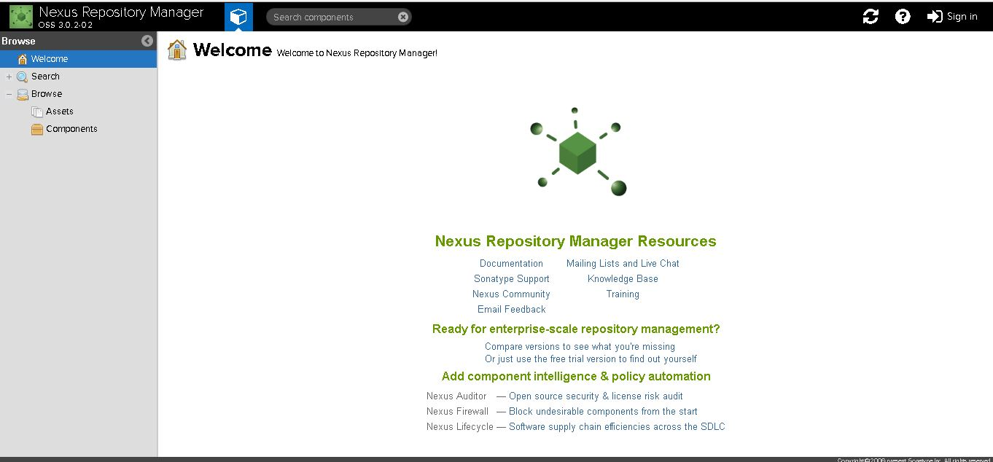](https://devopscube.com/wp-content/uploads/2016/09/nexus-setup.jpg)

To log in, use the default username and password.

Default username is admin

You can find the default admin password in /app/sonatype-work/nexus3/admin.password file. The path will be shown in the login screen as show below.

[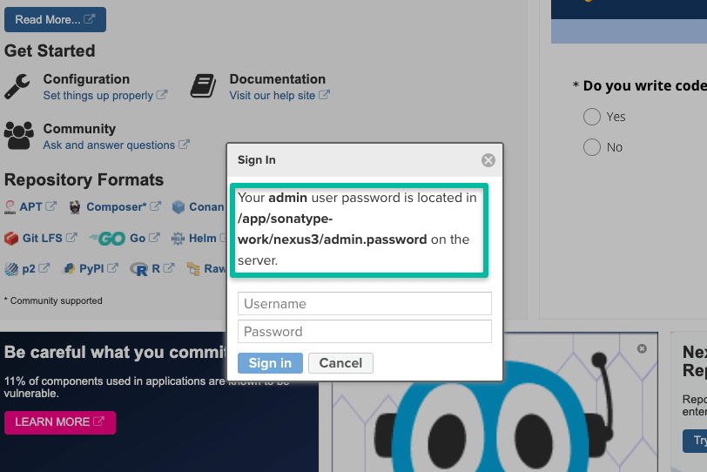](https://devopscube.com/wp-content/uploads/2021/04/nexus-password-min.png)

cat /app/sonatype-work/nexus3/admin.password

Once you login, you will be prompted to reset the password.

For stopping nexus, execute

sudo systemctl stop nexus

For restarting nexus,

sudo systemctl restart nexus

**Sonatype Nexus not Starting [Troubleshooting]**

Sometimes, if the server is enabled with SELINUX, you might get the following error. (Commonly on Centos Servers)

Job for nexus.service failed because the control process exited with error code.

See "systemctl status nexus.service" and "journalctl -xe" for details.

Execute the following command and see the actual error.

journalctl -xe

Check the output for the following SELINUX issue.

SELinux is preventing /usr/lib/systemd/systemd from execute access on the file nexus.

To rectify this issue, add a SELinux policy to allow Systemd to access the nexus binary in path /app/nexus/bin/nexus using the following command.

sudo chcon -R -t bin_t /app/nexus/bin/nexus

Now, start the Nexus server again.

sudo systemctl start nexus

**How to check the Nexus version in Linux?**

You can find the Nexus version from the Dashboard. Also, if you want to find the version from the Linux command line, execute the following command.  
curl --**include** --silent http://localhost:8081/ | grep Server